Ex. No: 1

CAPTURE FLAGS-ENCRYPTION CRYPTO 101

Aim:
To capture the various flags in Encryption Crypto 101 in TryHackMe platform.

Algorithm:
1. Access the Passive reconnaissance lab in TryHackMe platform using the link below-
https://tryhackme.com/r/room/encryptioncrypto101
2. Click Start AttackBox to run the instance of Kali Linux distribution.
3. Solve the crypto math used in RSA.
4. Find out who issued the HTTPS Certificate to tryhackme.com
5. Perform SSH Authentication by generating public and private key pair using ssh-keygen
6. Perform decryption of the gpg encrypted file and find out the secret word.

OUTPUT:
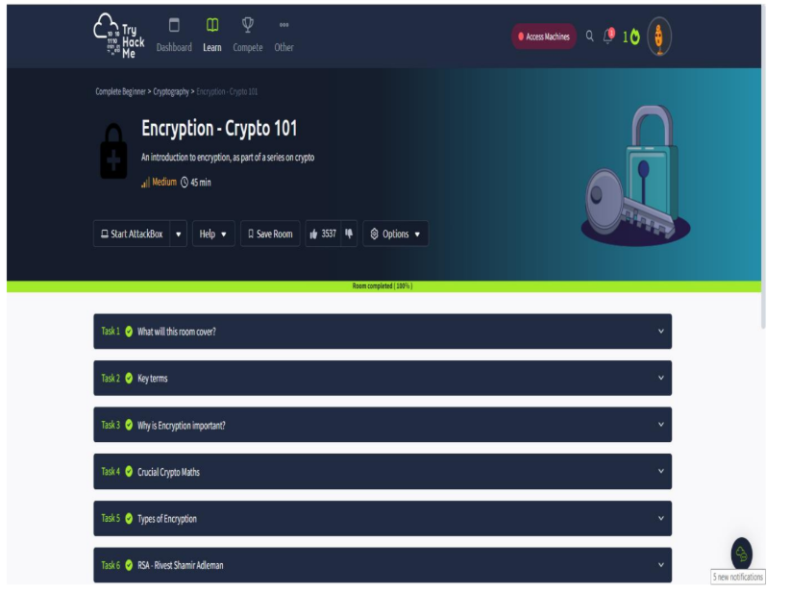
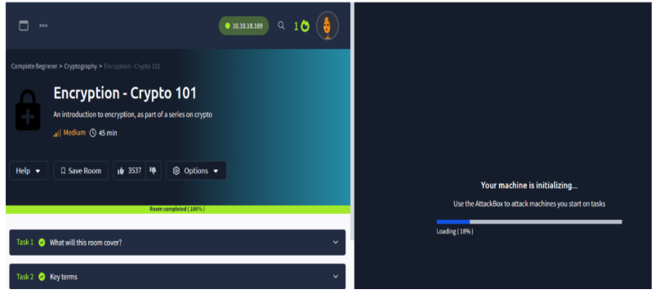

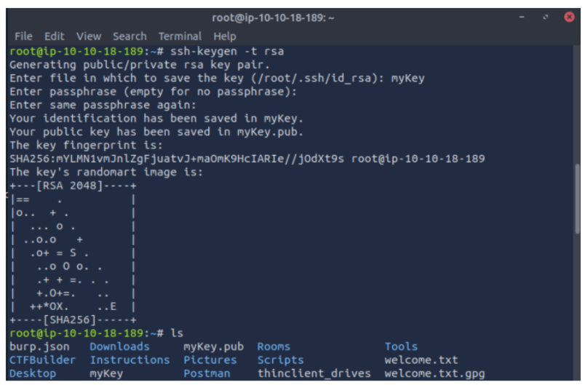

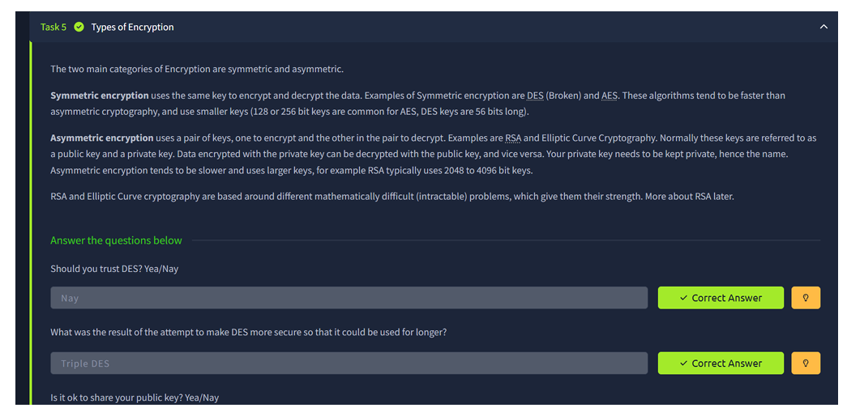

RESULT: Thus, the various flags have been captured in Encryption Crypto 101 in TryHackMe platform.

